LAB MANUAL 5
CLASS WORK
TAHA MUZAMMIL RASOOL
456279

TASK 1
#include <iostream>
using namespace std;
int main()
{
int x=1;
do{
cout<<"enter a number";
cin>>x;
}
while(x>0);

}

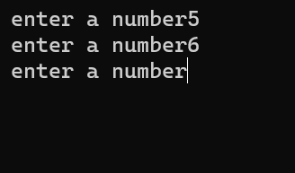

TASK 2
#include <iostream>
using namespace std;
int main()
{
double num1,num2,sum,sub,mul,div;
char operation,decision;
do
{
cout<<"enter any two numbers u need to be operated";
cin>>num1;
cin>>num2;
cout<<"press a for addition "<<endl;
cout<<"press s for subtraction "<<endl;
cout<<"press m for multiplication "<<endl;
cout<<"press d for division"<<endl;
cin>>operation;

if (operation=='a'){
sum=num1+num2;
cout<<"sum is equal to "<<sum<<endl;
}
else if
(operation=='s'){
sub=num1-num2;
cout<<"subtraction is equal to "<<sub<<endl;
}
else if
(operation=='m'){
mul=num1*num2;
cout<<"multiplication is equal to "<<mul<<endl;
}
else if
(operation=='d'){
div=num1/num2;
cout<<"division is equal to "<<div<<endl;
}
cout<<"if you want any other operation to run press y otherwise n ";
cin>>decision;
} while (decision=='y');
}

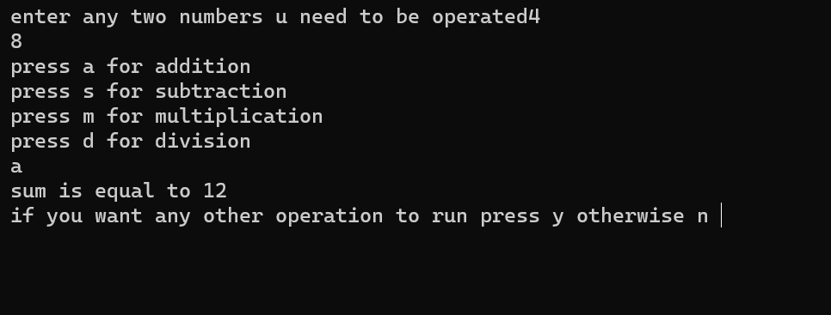

TASK 3 PART 1
#include <iostream>
using namespace std;
int main()
{
int x,z;
x=0;
z=0;
while (x<100)
{
x=x+2;
z=z+x;
}
cout<<z;
}
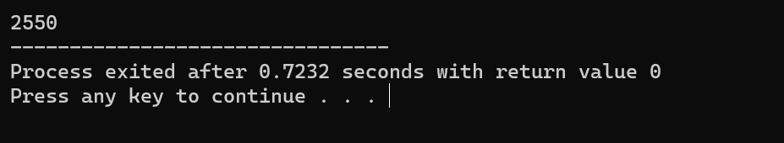

TASK 3 PART 2
#include <iostream>
using namespace std;
int main()
{
int x,y,z;
x=0;
z=0;
while (x<100)
{
x=x+1;
y=x*x;
z=z+y;
}
cout<<z;
}
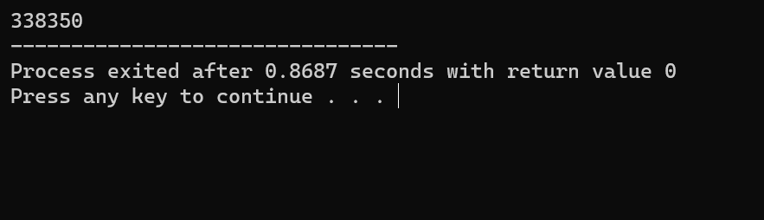

TASK 4 PART 1
#include <iostream>
using namespace std;
int main() {
int power = 0;
int result = 1;

while (power <= 20) {
cout << "2^" << power << " = " << result <<endl;
power++;
result *= 2;
}
}
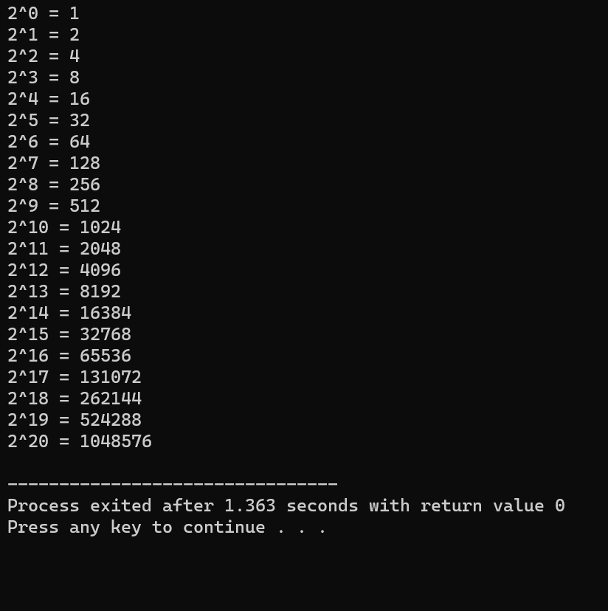

TASK 4 PART 2
#include <iostream>
using namespace std;
int main ()
{
int a,b,y,sum;
cout<<"enter any two numbers for sum ";
cin>>a;
cin>>b;
if (a > b) {
int y = a;
a = b;
b = y;
}

int z = a;

while (z <= b) {
if (z % 2 != 0) {
sum += z;
}
z++;
}

cout << "The sum of all odd numbers between " << a << " and " << b << " is: " << sum <<endl;

}
